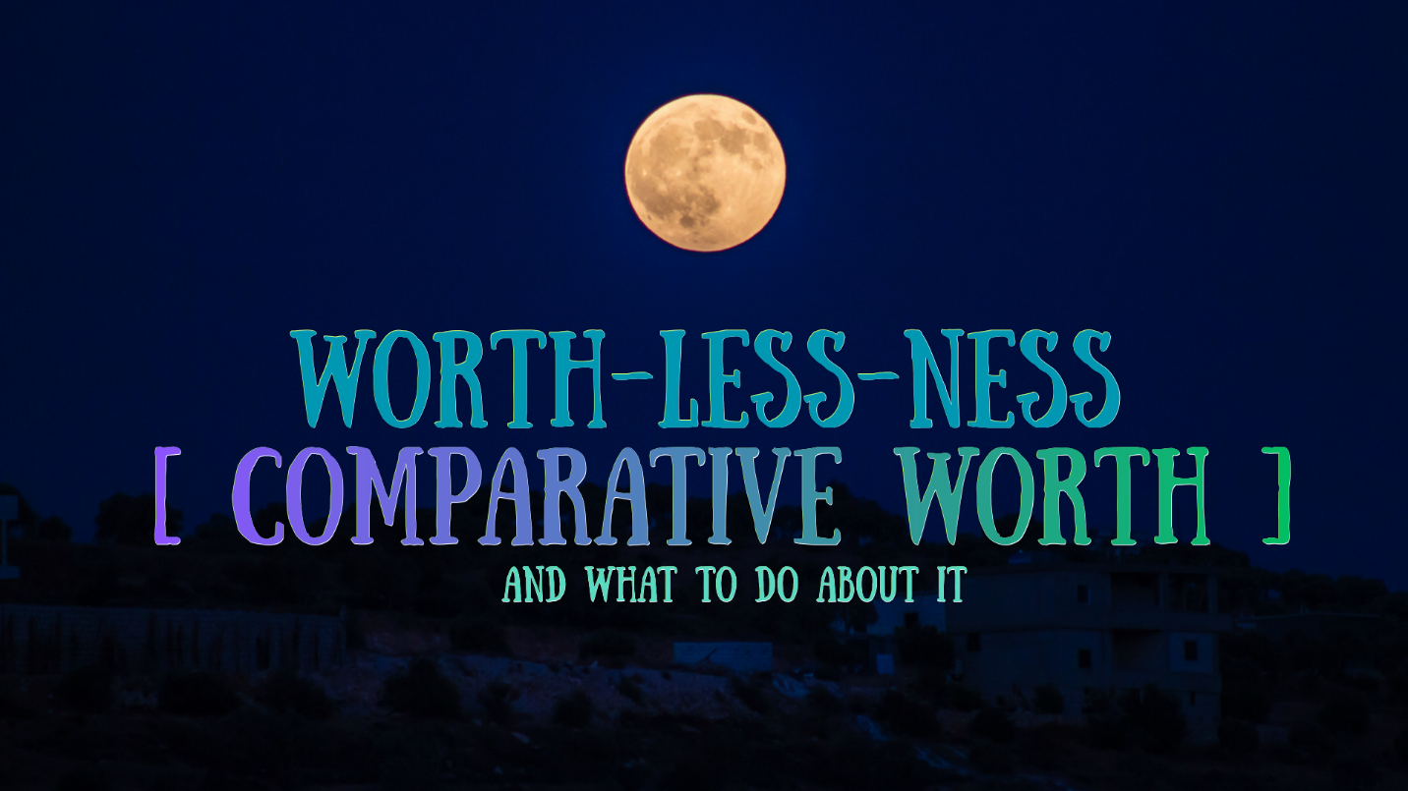

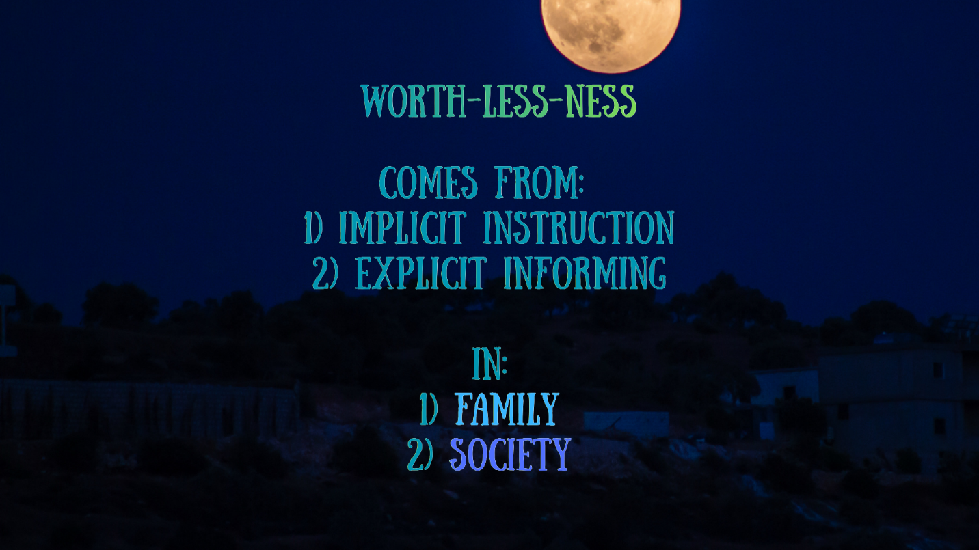

Let’s reflect on your:
Implicit signals of worth-less-ness in childhood home
(ignoring, neglecting, diminishing, lacking attention, mental illness in caregivers):

Explicit signals of worth-less-ness in childhood home
(overcorrecting, comparing, insulting, verbalized lack of care, controlling attention):

Societal messages of comparative worth you received:
- Materially (class, financial status, home type)

- Innately (color, gender, sexuality)

- Justly (achievement, effort)

- Righteously (religion)

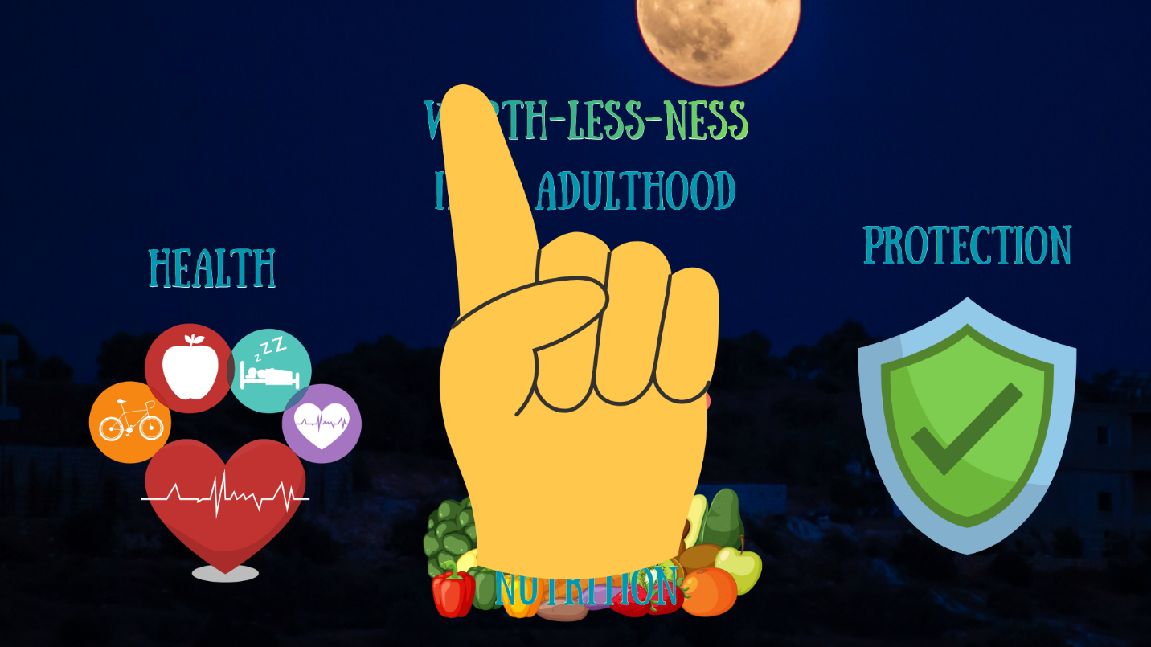

Young adult experiences of comparative worth
Work experiences (i.e. doing more for less):

Romantic experiences (i.e. receiving disrespect, dishonesty, dismissal):

Friends/Family adult experiences (i.e. lack of mutuality, respect, care):

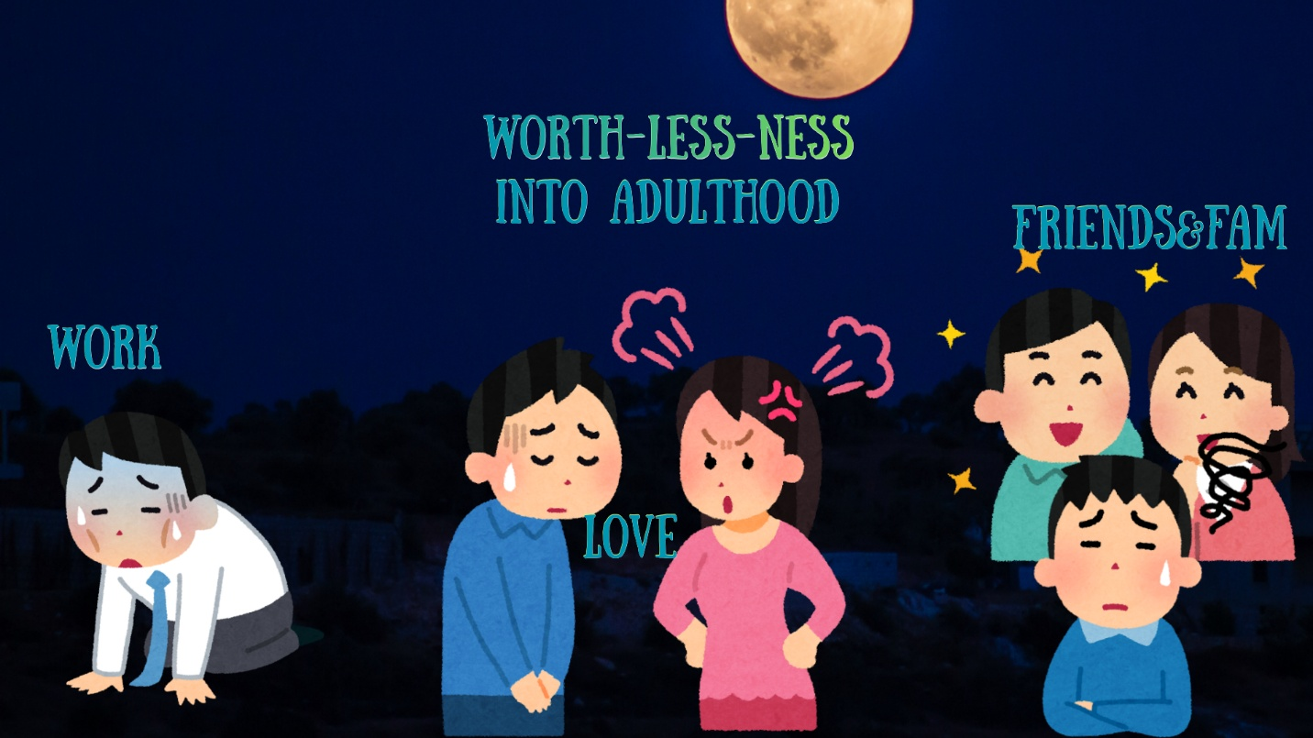

Did you make any mental/behavioral adjustments after each?

Did you acquire a cumulative sense “that’s just the way it is” from all?
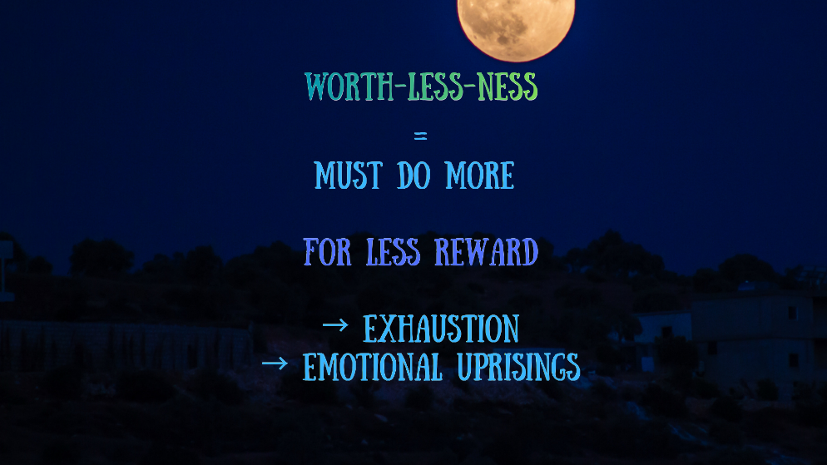
Behavioral outcomes:
If you learned to expect less than others – did you ever:
- Overcompensate? Work harder, make up for burdensome nature, earn worth?

- Accept/avoid? Give up, recognize uselessness in effort, save energy?

- Cycle? Overcompensation -> Burnout -> Collapse?

What caused each?
How did it look?
What were your explicit thoughts in the situation? Feelings?
Did your strategy ever change? How, when, why?

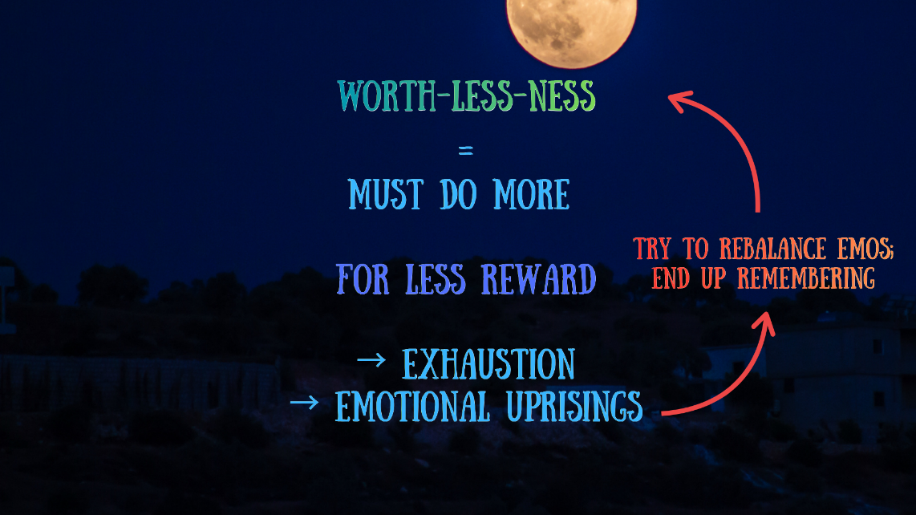
Emotional outcomes:
When doing more than everyone or collapsed in a stalled-out state, how was your emotional health?

Could you rebalance yourself? Was mental clarity accessible to provide emotional support?

Did you find yourself returning to your negative core beliefs rather than finding emotional comfort?

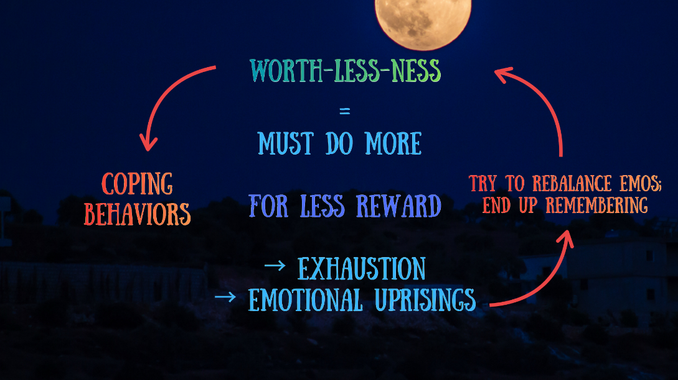

Coping outcomes:
How did you cope with the emotional discomfort of feeling worth-less negatively (substances, screens, human dependence, etc)?

How did you cope with the discomfort positively (exercise, journalling, contacting friends calmly, hobbies, reaching out to therapist)?

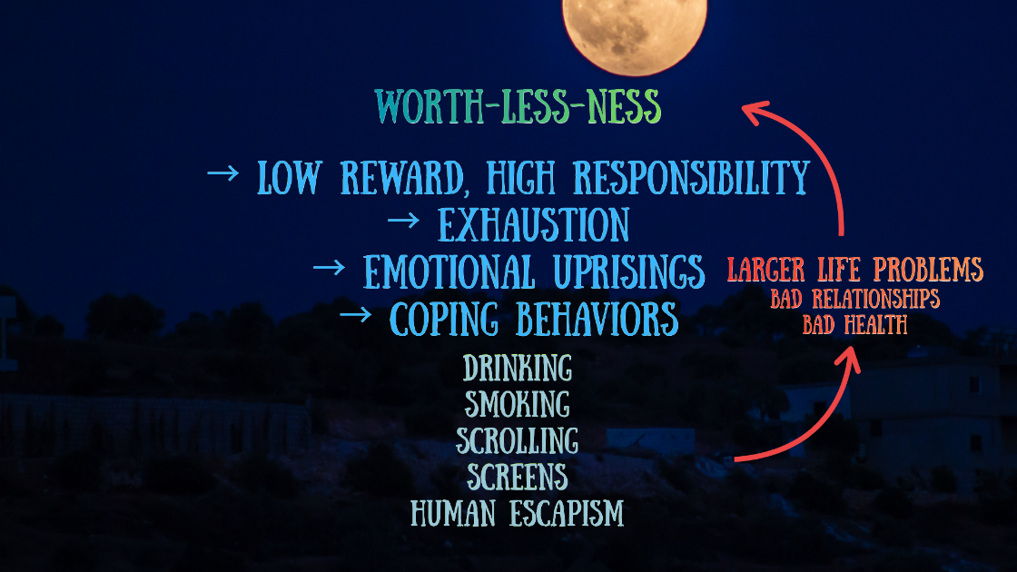

Larger outcomes:
Were there any positives created from these coping behaviors?

Were there negative life, work, or health outcomes from these coping behaviors?

Were there broader life disturbances / new problems created?

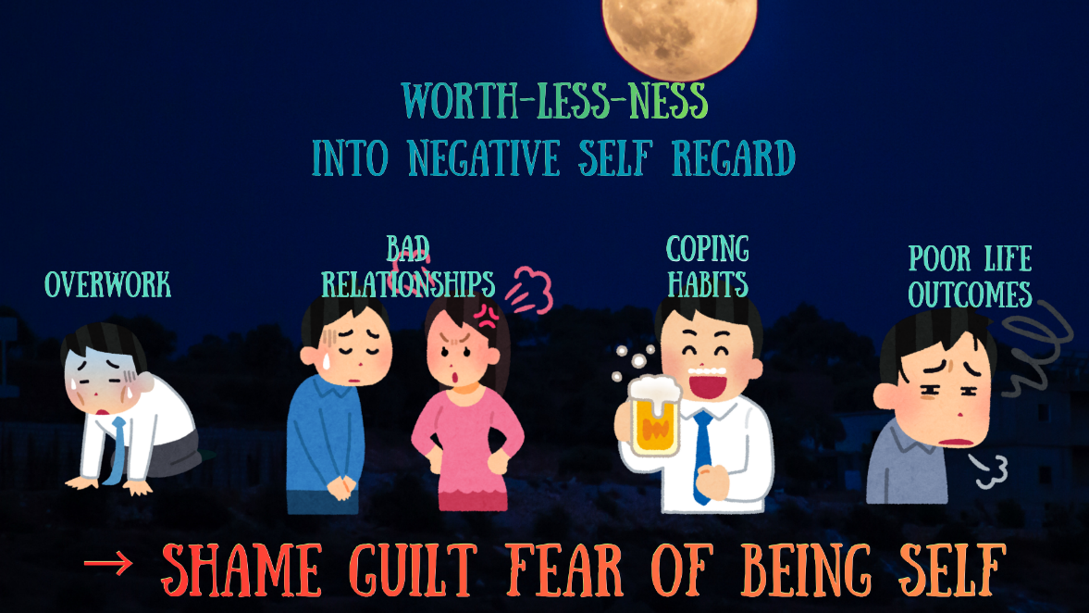

Self-esteem outcomes
Did any of this impact your sense of self/self-esteem?

Did you experience guilt, shame, anxiety, fear, confusion for being yourself?

How does a shaken sense of self feel?
What are the habitual thoughts that come with?
How do your behaviors change when you’re self-insecure?
How do your relationships change?

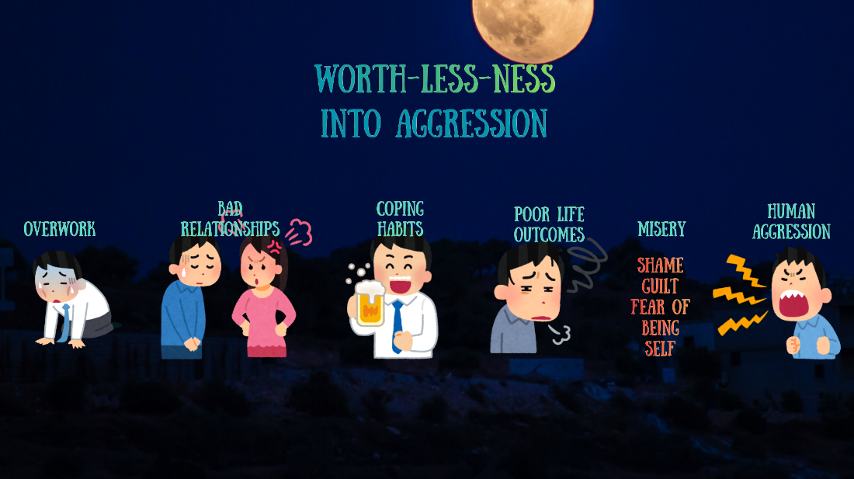
Ego outcomes:
Ego = sense of distance / difference from rest of humans
Worthlessness makes ego too big or too small – both are harmful, both can become negatively obsessed with ideas of self vs. world

Have you ever felt so worthless you can’t even be considered a “real, separate person”? (too small an ego) when/why/describe

Have you ever felt so worthless you are “completely unlike every other person”?
(too large an ego) when/why/describe

Did either/both come with increased suffering or relationship problems? Aggression toward self or other? when/why/describe

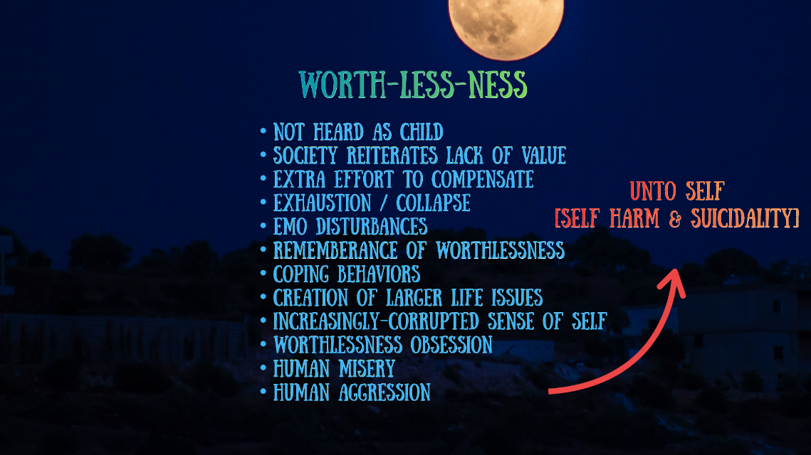
Conclusions:
Could worth-less-ness be the root of a good deal of your misery?

Could it explain social patterns such as repeated abusive relationships?

Could worth-less-ness be the cause of “why bother” self-sabotaging behaviors?

Could worth-less-ness explain your nervous system dysregulation? (overcompensate = fight/flight, collapse = rest/digest)

Could worth-less-ness be holding you in a state of life-less-ness?

Conclusions continued:
Has worth-less-ness in your life ever led to:
(yes/no, sit with the feeling, take notes):
overdoing it

underdoing it

emotional disruptions

substance abuse, tech addiction, relationship dependence

health and larger life problems

a corrupted sense of self

ego annihilation or thickening

misery, aggression towards self or other, suicidality & harm

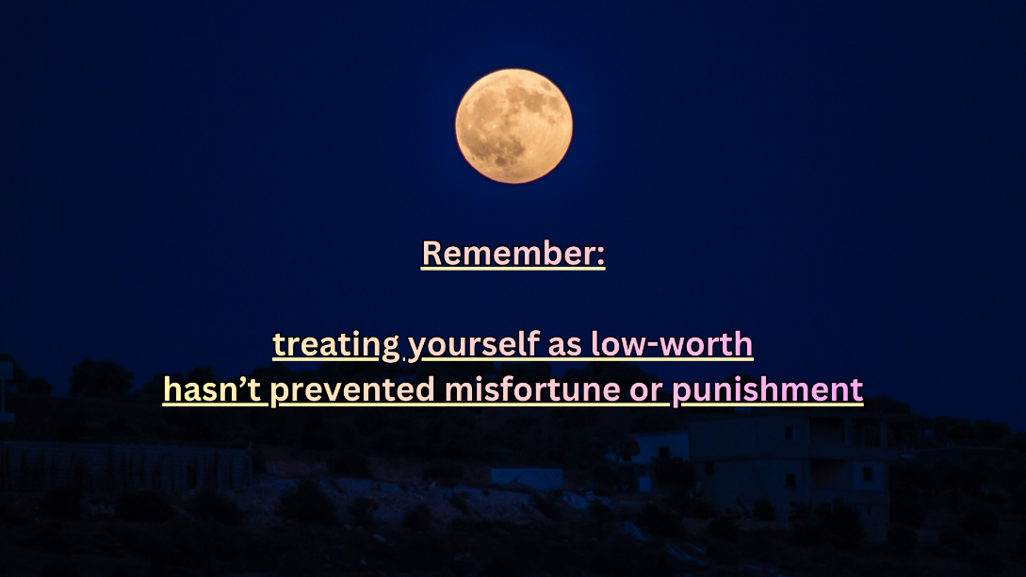
Conclusions continued:
Is there any superstition to treating yourself as less-than? Should it protect you to “accept your place and act appropriately”?

Has treating yourself as worth-less prevented pain or misfortune?

… Or has it guaranteed that’s what you received?

Have you lived in the shadow of worth-less-ness for many years?

… And has that allowed you to live the life you consciously want?

Are you ready to live the life you’re entitled to, like everyone else?
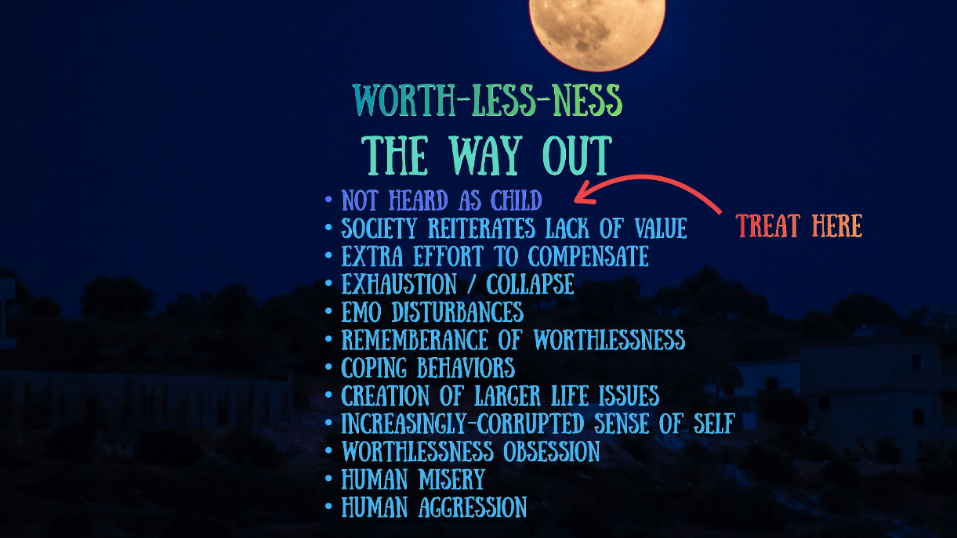
Solution:
Do you have relationships where you’re heard and treated with mutuality? With who?

Do they see your value? How do you know?

Can you extrapolate these feelings – if they see your value, could others? Could you already have more value than you estimate?

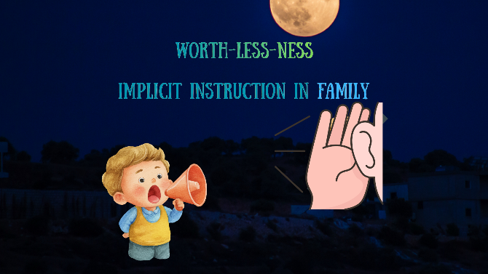
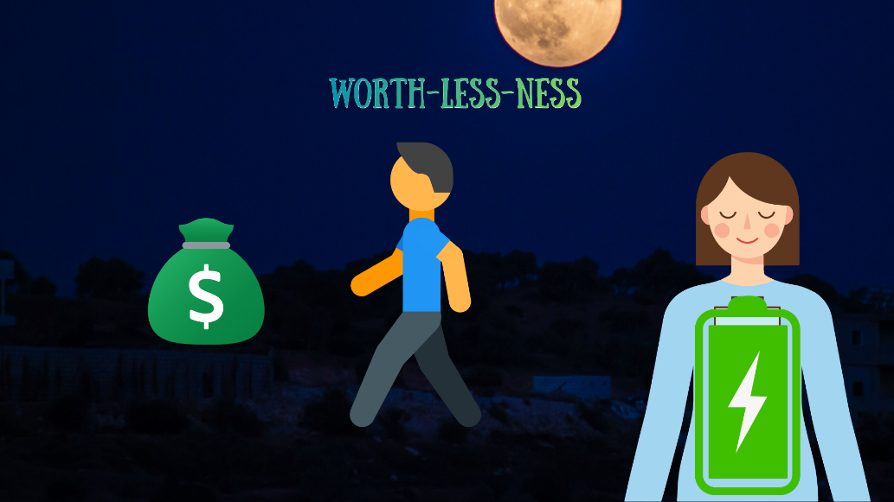

Can you assume equal worth for a day and challenge yourself to expect the same things in life as other people receive? Can you behave accordingly? What would that look like?

Can you extend this to multiple days? Weeks? A month?
What are 4 tasks you could complete to reprove your worth-equal-ness to yourself?
(i.e. say “no” to protect your energy, engage in hobbies, bring up an uncomfortable topic in a relationship, ask for something you need, high-level self-care that feels out of bounds)

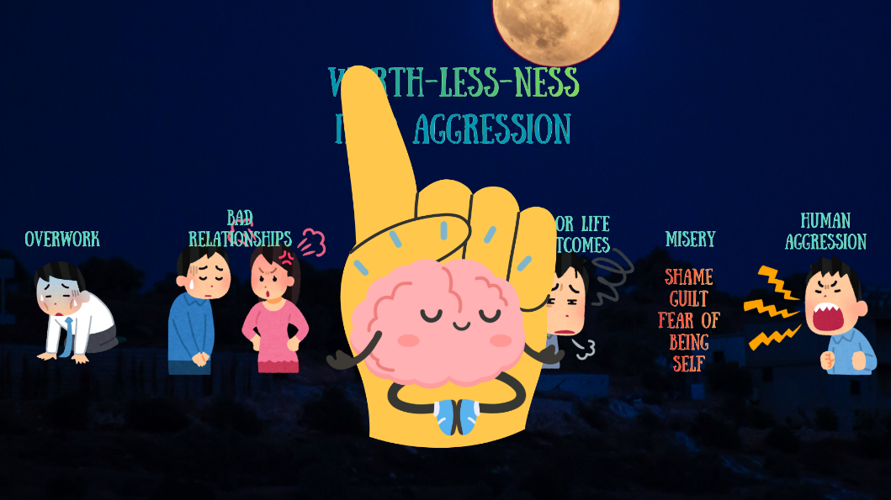
Can you feel a difference in your bodily ease when you behave like an equal human?

Can you actively process and integrate these new expectations, behaviors, feelings?

Can you sit with the anxiety and discomfort of challenging your habitual thoughts and behaviors? Can you see these as positive signs of confronting your worth-less-ness belief? Where might the stress come from and what does it actually signify? (i.e. fear of punishment for getting too big for my britches, per my family)

Are you ready to live outside the shadow of your early life experiences? What’s one thing that feels more accessible if you believe you have worth-equal-ness?

Results of the process:
From doing all these efforts for one month, can you rework any parts of your worth-less-ness core belief?

Can you see how early life experiences created a mirage of worth-less-ness?

Can you recognize that you are allowed to behave the same as other humans through challenging self-limiting behaviors?

Can you begin to rewrite your self-narrative to include 1) mind control installed by family and society 2) eventual rediscovery of your real worth? Practice in 2 sentences:

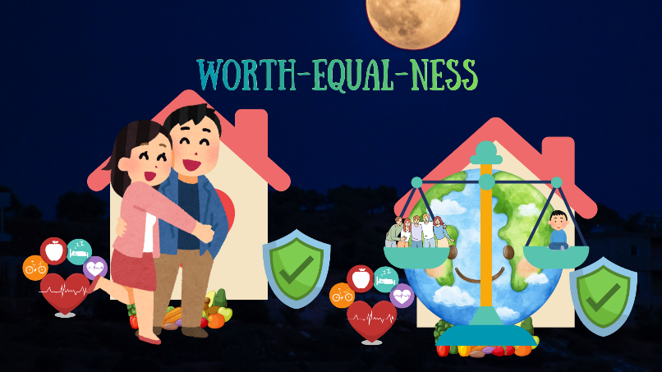
What would you like to do with your life, having the same rights to be here as everyone else?

