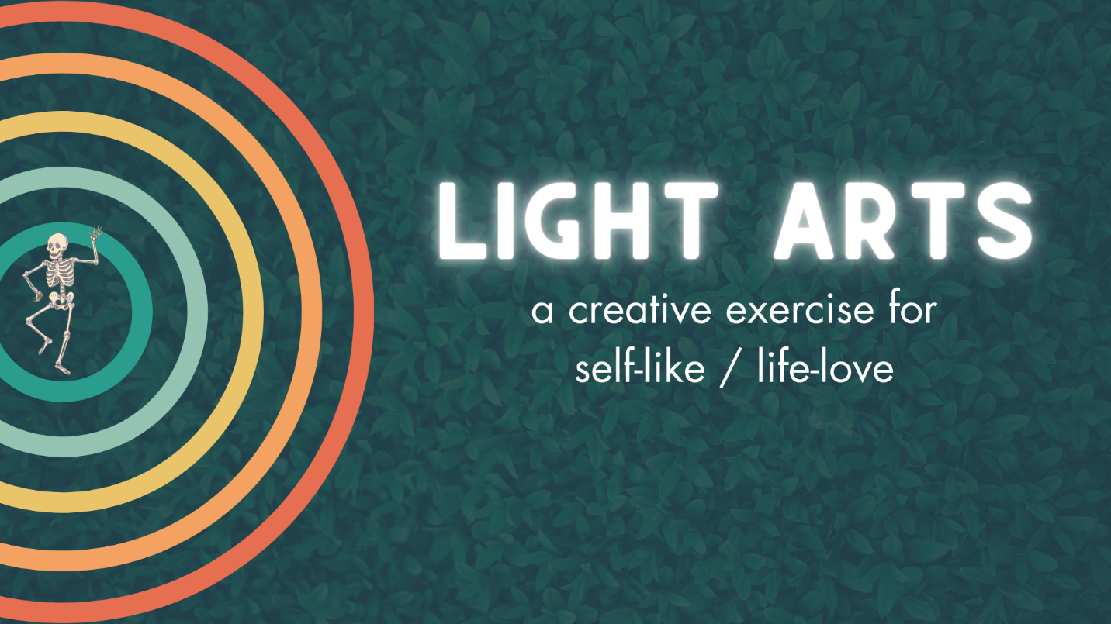

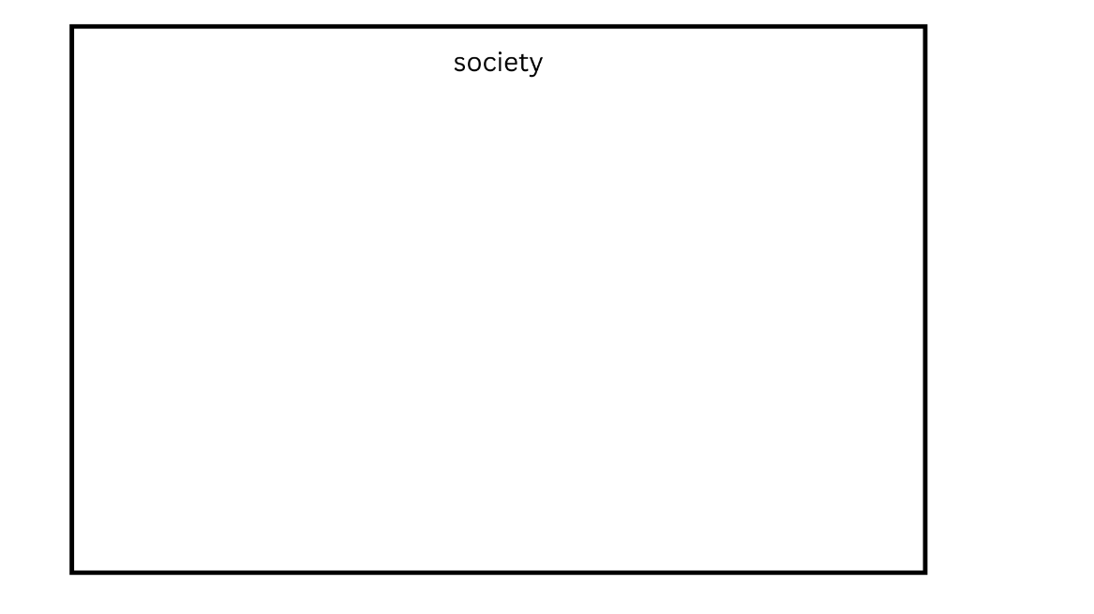
This is society.
The human-created world of work and buildings and social norms. The economy. Access to need fulfillment. How does society feel? Don’t run from the tension that I presume has gripped your body. But characterize it. And if you can, do it visually. With color, texture, image, symbol.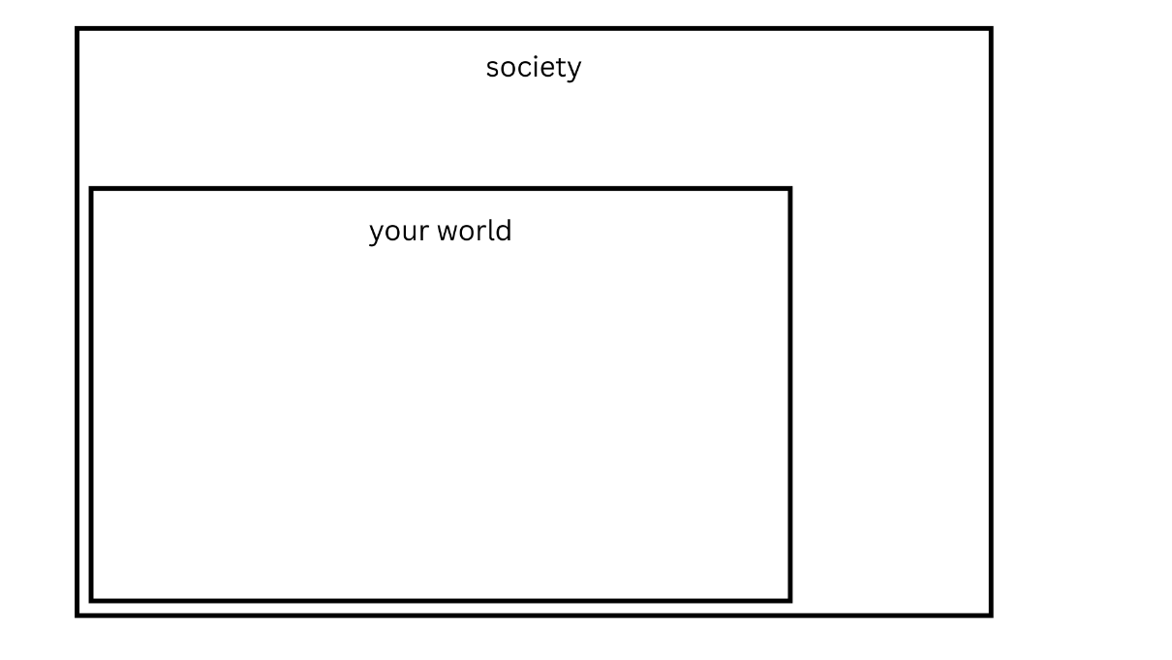
This is your local world. Where you go every day. What your regular, in-direct-eyesight experience entails. What you see, personally.
It fits within society but it is unique to you. Your little corner of… everything that exists in the human world. This cake exists and you bit off what chunk of it? What is your niche? Feel into that.
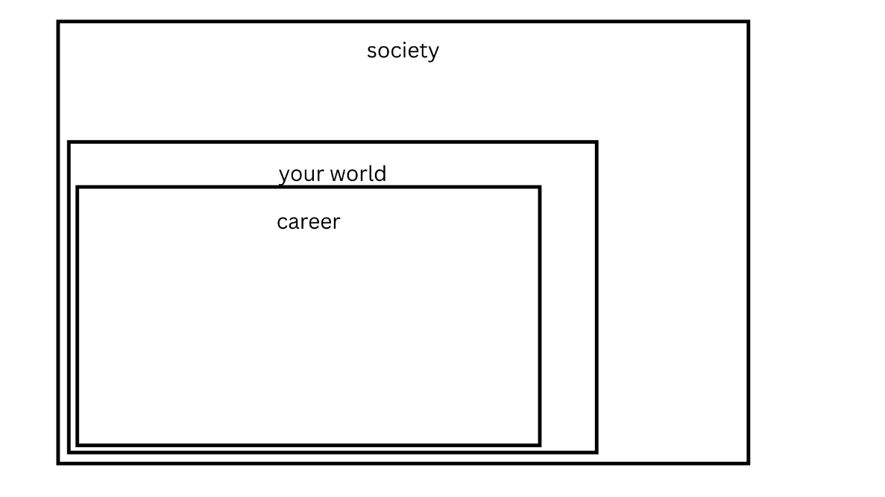
This is your career, purpose, thing you work on dedicatedly over time. Maybe it’s your job. Maybe it’s your volunteering at the animal shelter. It’s what you value doing, across expanses.

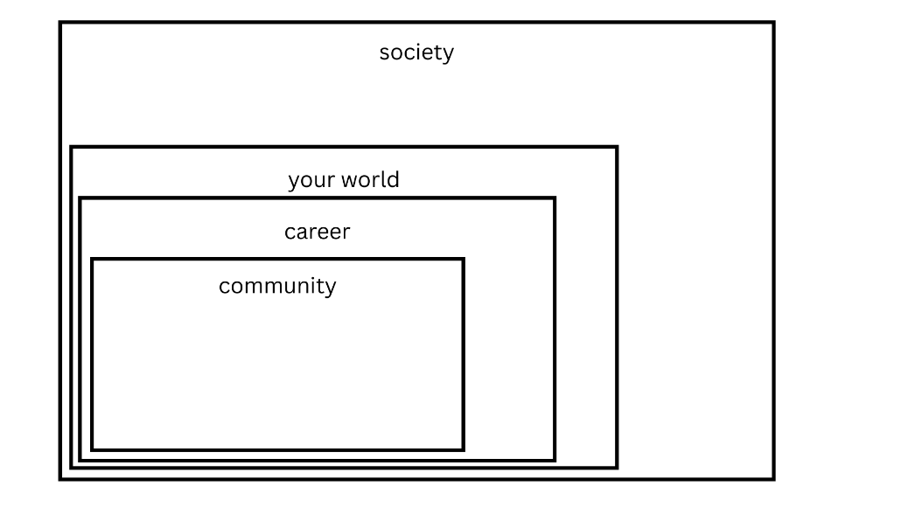
The next shape? Will be community. This is your relational life. Your social network. If your community and your personal relationships feel separate, make a separate shape inside.
Feel into both of those aspects of your life.

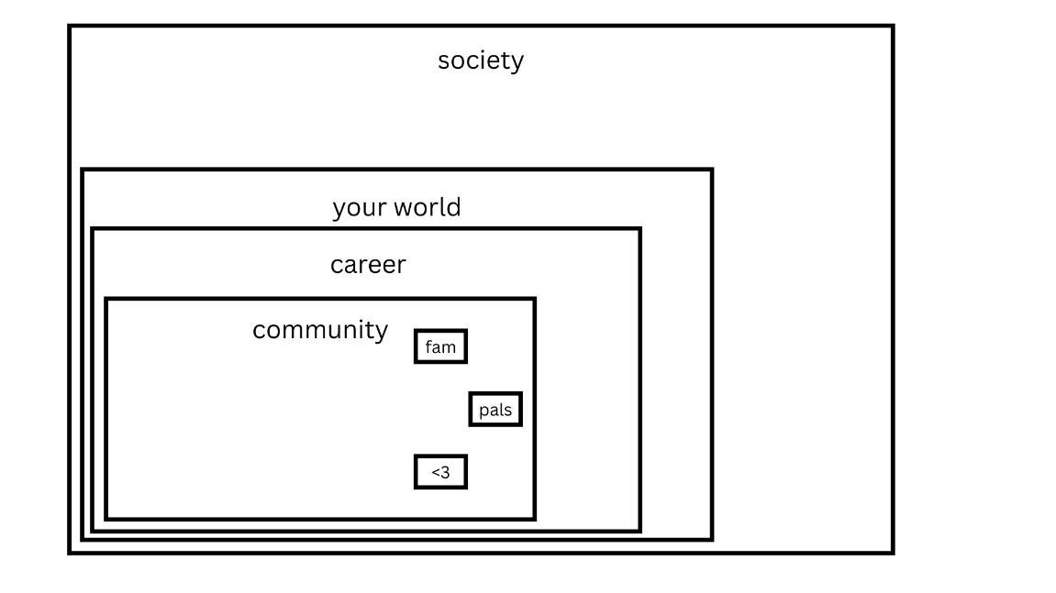
Within that, make a shape for each of your important relationships or relationship types. Depending on which one feeling intuitively correct to you. For example, “romance,” “workplace,” “family,” “friends.” OR “Ben,” “Jerry,” “Leslie,” and “Donna.” Take a minute, decide which feels better for you, draw your shapes, feel the vibes, or keep listening.
These shapes can be stacked within each other or spread through the personal life shape like holes in swiss cheese. But leave room in an area of the Community or Relationship shape to keep with the concentric tetris we’ve been playing.
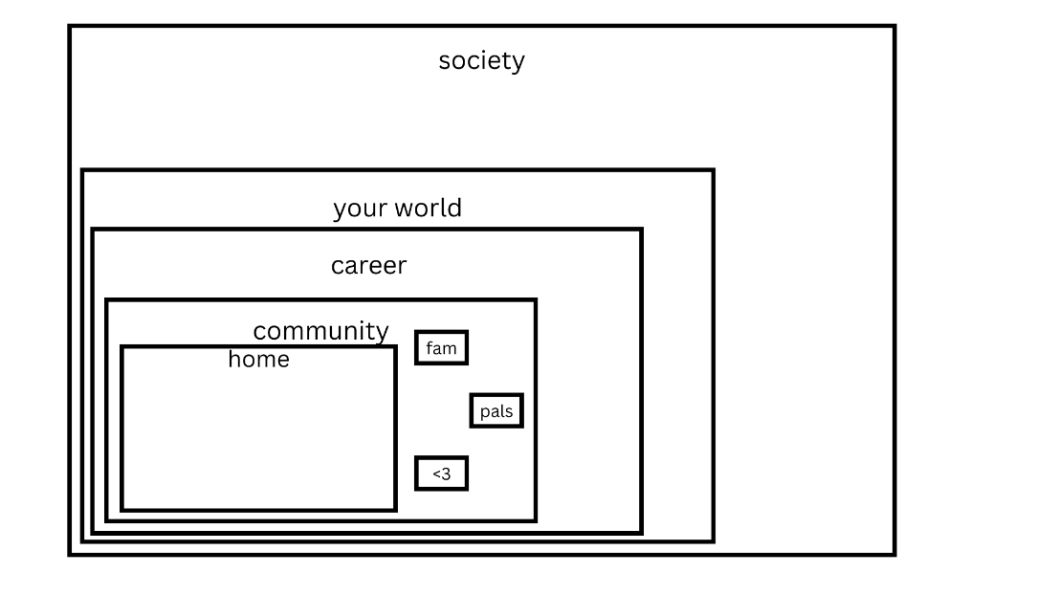
This is your home. Where you sleep at night and the surrounding blocks. How have you made your home? How’s the placement? The energy? The outfitting versus your needs? What are the senses and sensations in your dwelling?
Maybe there’s a person that fills your home and you’d prefer to put them here. How does that characterize your home-sensation? Feel into that
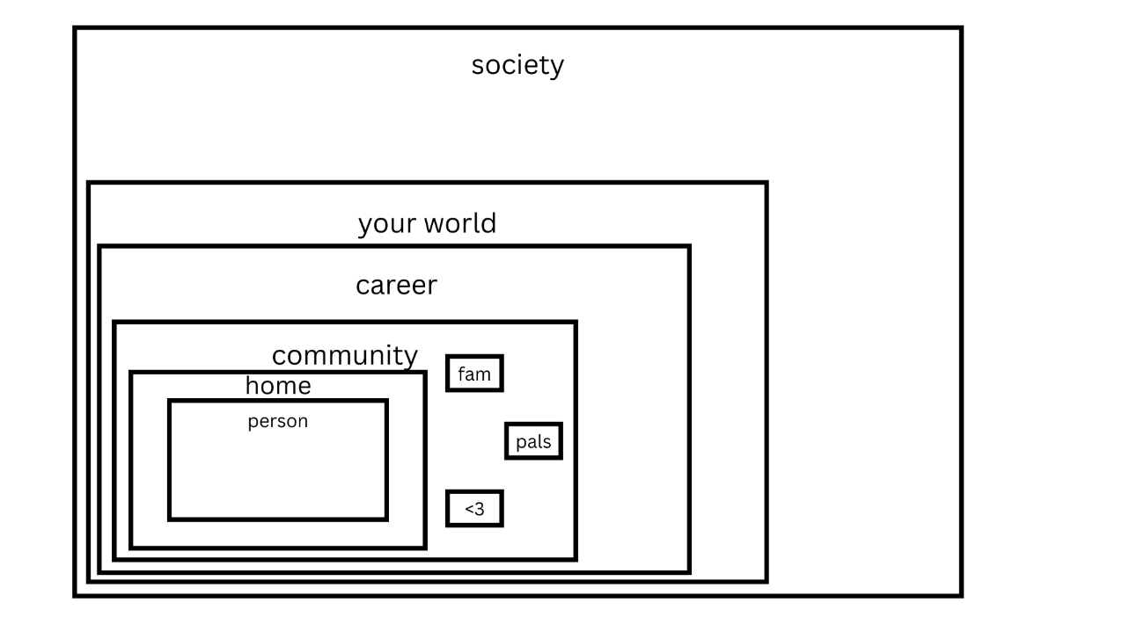
We’ve finally gotten down to you. This is your being. Your self with a small s. Your identity, mentally and physically. The boundary between you and others. How does it feel inside that space? You might consider who you are and how you are. But try to stay out of your words and in your feelings. Don’t shame spiral or get chatty. Just feel in the orb that is you.
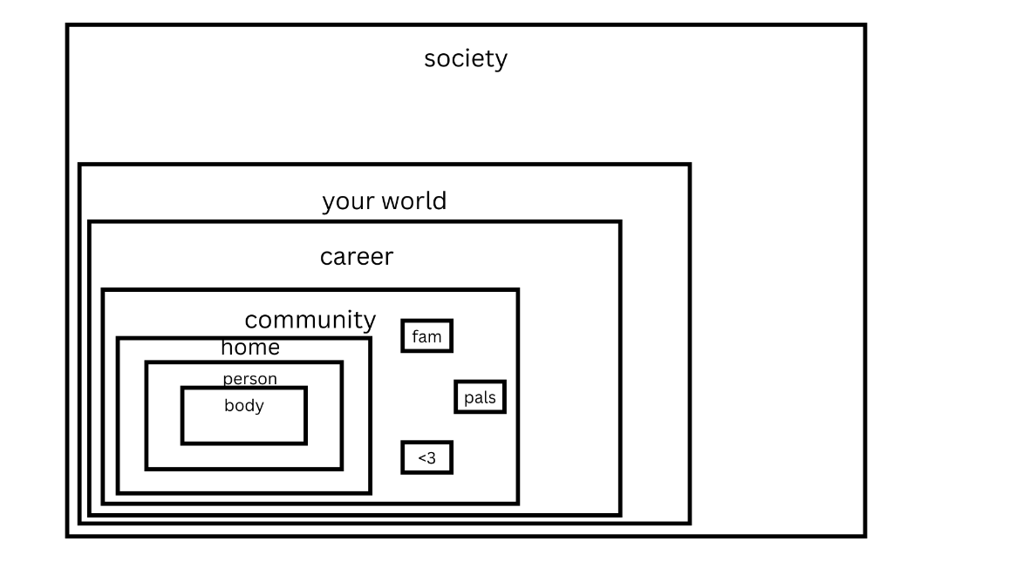
This is your body. Your meat. The confines and workings of your physical being. Your bones, blood, joints, and cushion.
How does it feel being in there? Pains or dysfunctions? What are the feelings in each part, and as a whole? What’s the prevailing judgement or assigned emotion?

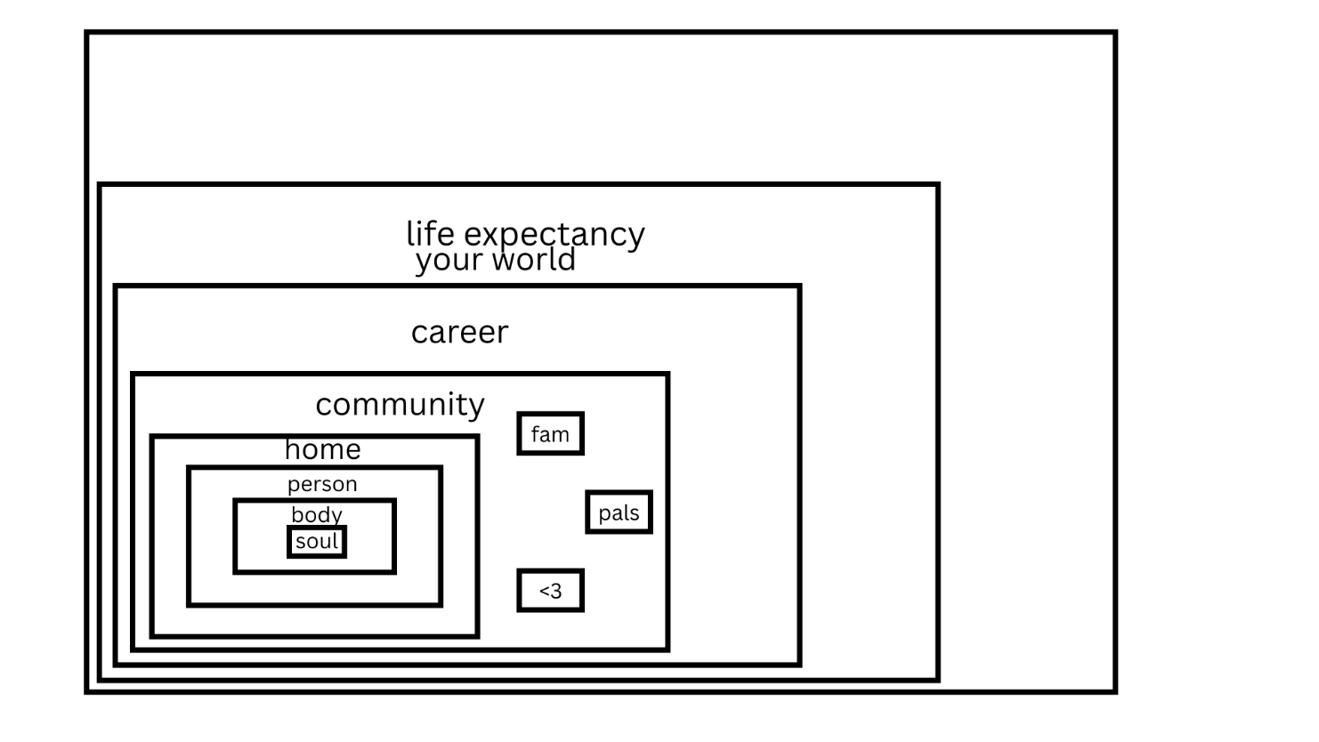
One last shape goes within. It should be prettyyyyy small by now. A dense little shape.
This is the nucleus of what you’ve drawn. The center of it all and the hardest to see. But that doesn’t mean it’s lacking in contents. Rather, those contents defy space, unlike the rest of the shapes we’ve drawn.
This is your soul-thing. Your core being. Your spirit. The sum of your emotions, if you prefer to keep it psychological.
This is the nugget that expands to the size of the universe which powers your body and self. It’s the source of your authentic actions. When it motivates you to do something, you don’t question it. You’re already moving. It’s a flame that’s aways alit, but sometimes dimmed by inner darknesses getting in the way, making it hard to find inside you.
Feel it now.
Spend as much time as you can, feeling into this space.
You know, everyday. Please come back to this core of your atom, as often as you can.

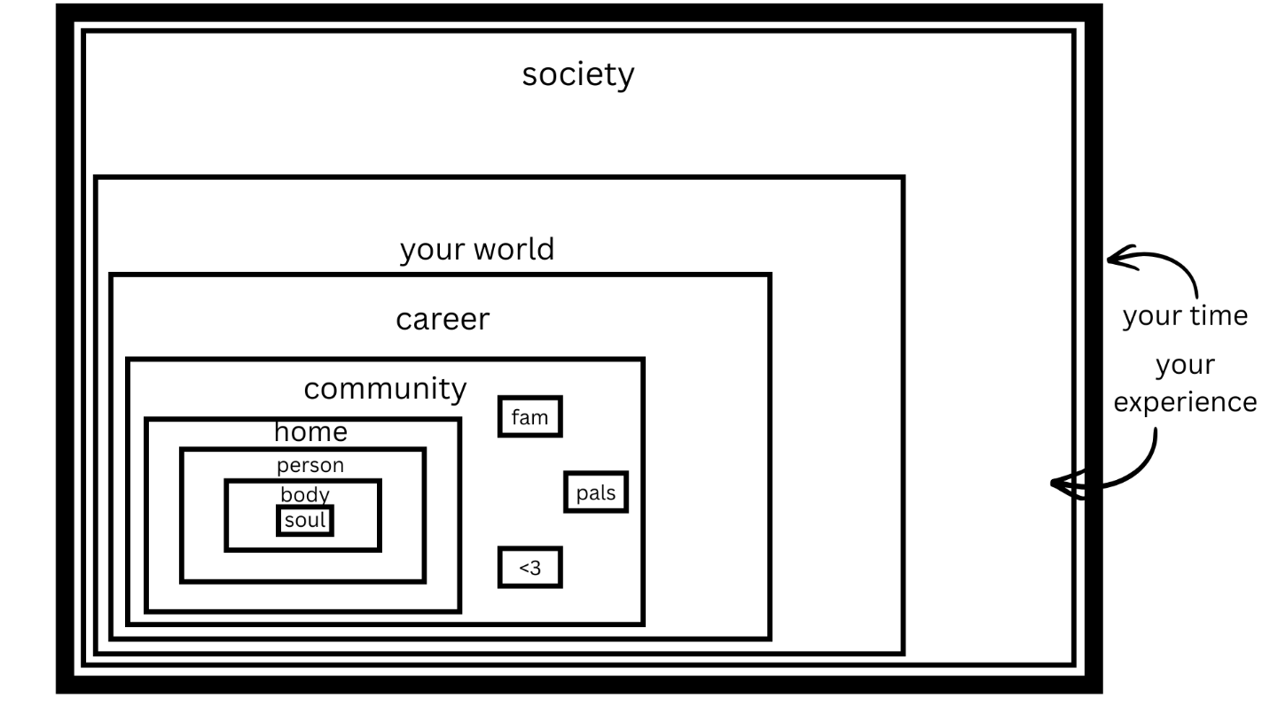
So this whole paper… this is your existence.
It was once undefined. Completely undetermined. Omnipotent. Until those first lines were drawn. Thus determining the qualities of every other development to come.
Your life, as a fetus? The blank paper.
Your life, as soon as you entered the structures of society? Already limited. Your life, in many ways, already influenced.
Draw a thick line around the entire thing. The largest shape you drew – society.
This line? Is your time.
Linear, but bending around all the events within. Confining and making form.
These shapes and colors and textures contained inside? Are the nature of your time.
The are your experience. The filling of your time. The reasons that it can be fun and fulfilling and connective. The reasons that it often hurts. And becomes a fearful enemy.

Hopefully you had feelings during each of these shape drawings or shape imaginings.
A way that your sensations tilted: positive or negative.
Maybe you’ve had more visceral or complex feelings.
Or even tastes, sounds, smells, that came to you.
Maybe visuals. Images behind the eyeballs.
Or ghostly feelings. Like someone tugging at your ear or squeezing your arm while you considered a shape.
Great. Evidence and data.
Gather those little brain wisps and body sparkles up in the context of each label we described here. Get a prevailing sense of each item.
Consider each of these shapes, each of these frameworks of your life, one at a time… and decide how to characterize it with color, texture, weight.
If each was a stand-alone object that could be constructed of anything, filled with anything, what would it be made of? What hue would it sport?
You might want to consider “if this was a box, filled with other boxes, each holding some items as a form of organization… what would be in each box?”
And for the art project or deep imagining portion of this… Please represent, visually, how you feel about it each one using color and/or texture. Emojis, if that works better for you. Whatever comes up for you. And fill the shapes in.

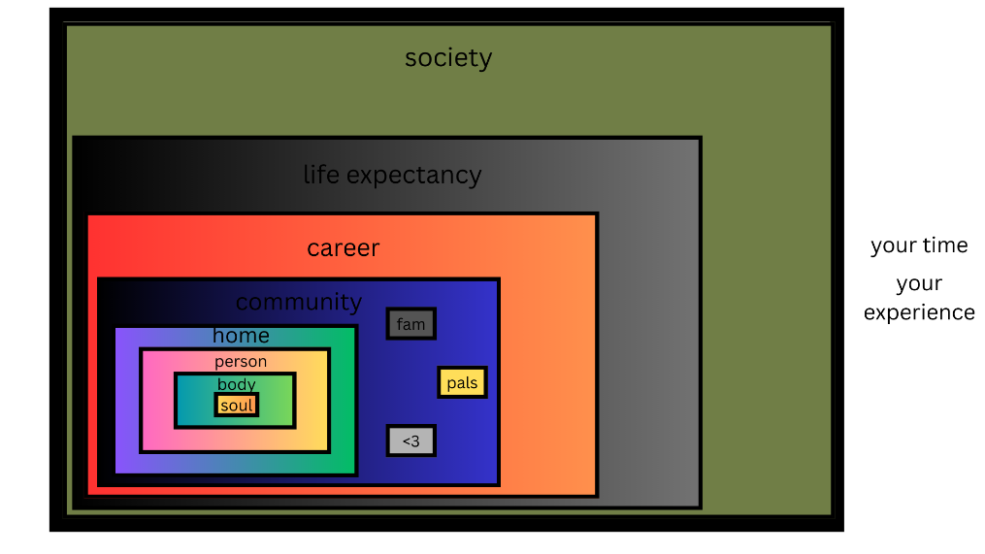

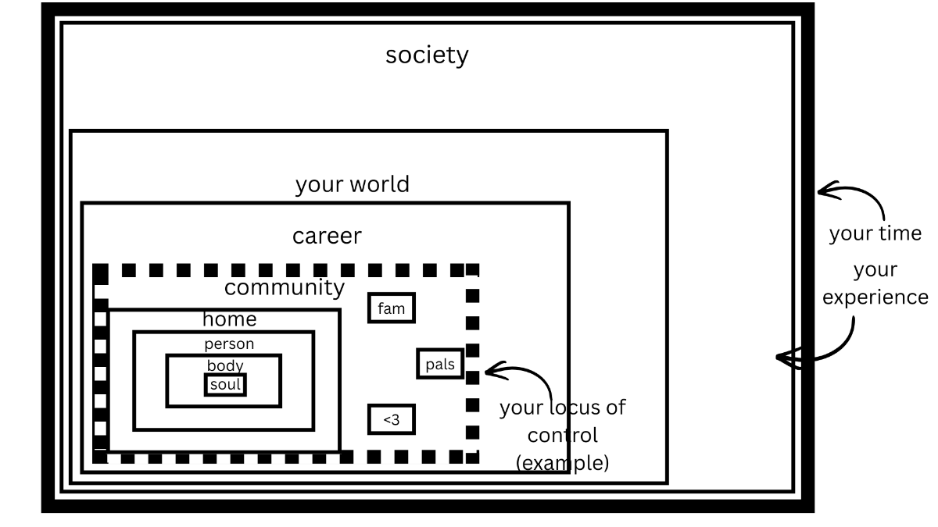
Determine which containers are in your control….
Let go of the ones outside of it for now.
Put your effort towards the ones within it.
And if you’re realizing that your colors and textures take a dump at a certain container… AND you don’t have control over them from there on out…
Go ahead and draw a new thick line around those shapes. No, your life, time, and experience don’t end here, of course. You still need to be tuned in and responsive to these containers.
… But if you can consider these the barrier around your effectiveness… the perimeter that defines your locus of control. You have a clear marker of what you can viably work on, for great result. And what is not as worthy of persistent thought or behavior, in this moment.
Not to say there won’t be changes that give you more control or efficacy in the future.
But the containers and contents you can’t change or can’t change right now? Accept them for how they are. Going through your fears about them. Getting to the bottom of the well. And asking “now what?” and accept them as a sortof foundation to your experience.
Yes, these things are happening. And from there, what are you going to do?

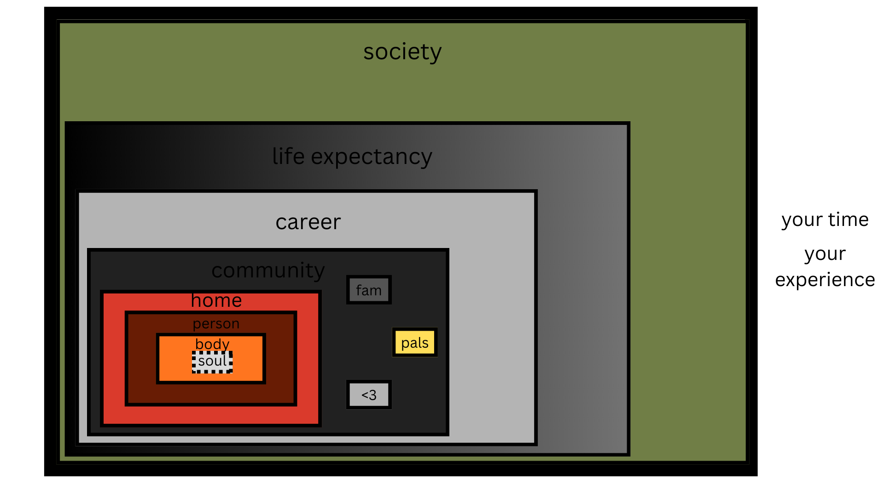
You’re going to refocus.
Pay attention to the shapes you CAN affect. And then care for them. Starting from the smallest container.
Re-organize from the smallest shape.
Your nucleus. The universe-marble that lives in your stomach.
You want to start from the center and work your way outward, amplifying the energy at your core so THAT defines the shapes of the containers around you… all the way up to the new society that we have to toolbox, together… rather than the other way around.
It’s the way to effect real change.
You can improve your core container through listening and responding to the experience within.
Cleaning it. Organizing it. Making it beautiful.
And if you keep putting effort to that, day after day, you’ll change everything about the way you live. Getting rid of what doesn’t work for you and expanding what does – all the way into the other containers.

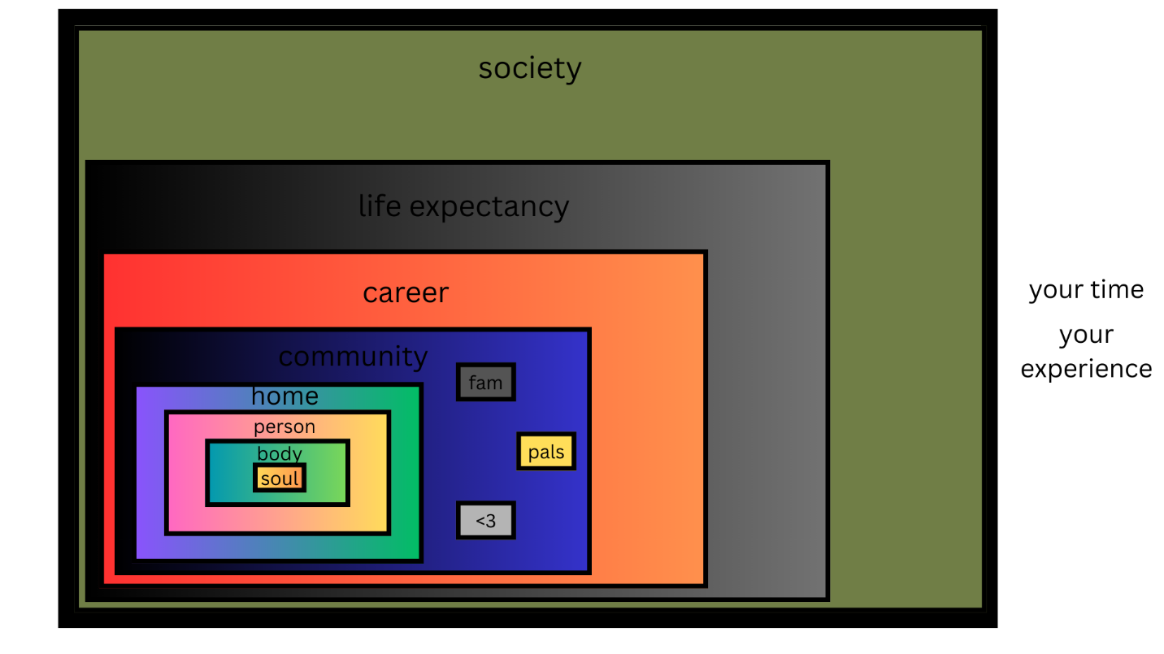
When you’re changing your life experience from the core of your being (the nucleus of your life experience) – from the most inner container, out - rather than trying to work your way from the largest containers, inward - you’ll begin to feel and amplify self-love in a (opposite of vicious) circle that changes, quickly.
When you decide to change this picture, in your mind or your hand… start with trying to improve the experience contained within your chest. Cater to your feelings. Baby them.
And then, from there, your body.
The two will feed each other, so your actions can support both, quickly.
Then they’ll carry over into redrawing and refilling the shape of your self.
Then, into your home environment, when you’re feeling good enough to take action in that environment.
Then, into your relationships, as you find comfort and safety and opportunities for communing within your dwelling.
Then, into your purpose, as you have more energy for work and more social support for the days that suck.
Then into your world, as everything from the bottom-up has radically shifted and changed tone.
You’ll have a whole new life, as far as what you see, smell, feel, and do each day.
Each action you take on this mission will refill you, by refilling the frameworks of your existence, with peace, contentment, appreciation. And reduce frustration, defeat, and hopelessness… a tenuous sense of existence… because every behavior will count.
Because the container is so small. And so within reach. You can read it and respond to it. You don’t require, say, the media, to tell you what’s happening, in an ever-propagandized version of telephone.
It is directly observable and impactable, while so many other things feel indirect, unchangeable, and defeating.
No one can observe, report on, or care for the center of your world like you can. No one can re-draw that container or refill it. As far as the containers within the “self” go, you are in control.
You just have to get started.

